2026 Scholarship Program
The South Carolina Association of Hazard Mitigation announces the 2026 Academic Scholarships. Applicants should contact the SCAHM Scholarship Committee Member directly for more information.

Academic Scholarships:
- $500 scholarships are available for a high school seniors, college freshman, or college sophomore attending any four (4) year college or university of their choice.

- $500 scholarships are available for a college juniors, college seniors, or graduate students attending any four (4) year college or university or graduate program of their choice.

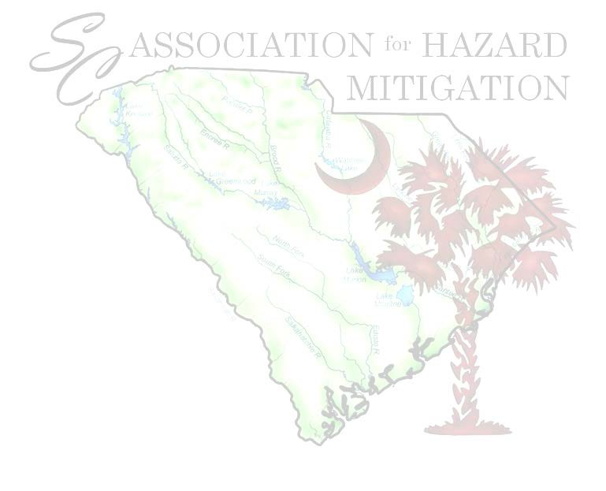
Program Guidelines & Priorities:
- Graduate from high school or complete a home school program as prescribed by law;
- Be a South Carolina resident at the time of high school graduation and at the time of college enrollment
- Be a US Citizen or a legal permanent resident (who meets the definition of an eligible non-citizen according to State Residency Statues).
- Applicants must have a minimum GPA of 3.0 on a 4.0 scale and plan to attend a four (4) year college or university to apply for both scholarships.
- Students with a record of volunteerism in the community in non-school sponsored activities and participation in extracurricular school activities. Documentation must be submitted.
- Scholarship recipient(s) will be announced at the SCAHM Conference held in Greenville, SC during their annual Business and Luncheon Meeting on March 18th.
- Applicants must pledge to submit a Final Acceptance Letter to the SCAHM Scholarship Committee by their college or university.

Email the completed typed application package to:
(This includes application, essay, school transcript, and resume)
Penny Ayers
Floodplain Specialist
Berkeley County
penny.ayers@berkeleycountysc.gov

The applications will be reviewed and recipients selected by a committee consisting of SCAHM Executive Board of Director’s Members. The scholarships will be awarded in 2026.

Applications may be downloaded from SCAHM website at www.scahm.org. In addition, you can also learn more about the SCAHM mission and goals.

Please submit any questions to: penny.ayers@berkeleycountysc.gov or call 843-719-4266.

SCHOLARSHIP APPLICATION 2024

Please type or print your answers in black ink.
1. | Last Name: |  |  |  |  |  | First Name:
2. | Mailing Address: | Street Address |  |  |  |  |  | City |  |  | State | Zip Code
3. | Daytime Phone Number: |  |  |  |  |  | Email:
4. | Date of Birth: | Month |  |  | Day |  |  | Year | Gender
5. | Cumulative Grade Point Average (GPA):  (On a 4.0 scale) |  |  |  |  |  |  | *Attachments Required:  Proof of GPA & Recent school transcript
6. | Name of High School:
6. | Street Address |  |  |  |  |  |  | City |  |  | State | Zip Code
7. | (If your resume or activities sheet answers question 7, please attach and skip to Question 8.)
7. | A. List any academic honors, awards and membership activities while in school:
7. | B. List your hobbies, outside interests, extracurricular activities and school related volunteer activities:
7. | C. List your non-school sponsored volunteer activities in the community:
8. | A. If you have decided on what college you will attend or currently attend a college, please list school name:
8. | B. If not, list your top 3 college choices: |  | 1. |  |  | 2. |  |  |  | 3.
9. | Is your parent or legal guardian a member of SCAHM?
9. | If your answer is ‘yes’ please answer blocks A, B, C in block 10. If your answer is ‘no’ go to item 11.)
10. | A. His/her full name:
10. | B. Name of Jurisdiction or Agency: |  |  |  |  |  |  | C. Department Name:
11. | Name & address of parent(s) or legal guardian(s):  (Include address if different from your own listed in Question 2)
11. | Street Address |  |  |  |  |  |  | City |  |  | State | Zip Code
12. | On a separate sheet please write an essay (250 - 500 words) answering the questions below:  Describe how volunteer or community service has shaped who you are today and what community service has taught you. Also, discuss in your essay about any challenges or obstacles you have dealt with and overcome in life and how this will help you succeed in college and beyond.

STATEMENT OF ACCURACY FOR STUDENTS
I hereby affirm that all the above stated information provided by me is true and correct to the best of my knowledge. I also consent that if chosen as a scholarship winner my picture may be taken and used to promote the SCAHM Mission and Goals relating to the scholarship program. (Winner may waive photo due to unusual or compelling circumstances.)

I hereby understand that if chosen as a scholarship winner, according to SCAHM Scholarship policy, it is my responsibility to remit to SCAHM my final acceptance letter from the college or university that I will be attending in the fall of 2026 to receive my scholarship award.

I hereby understand I will not submit this application without all required attachments and supporting information. Incomplete applications or applications that do not meet eligibility criteria will not be considered for either scholarship.

Signature of scholarship applicant:
Date:

CHECKLIST

Application Essay Resume/Activity Sheet School Transcript

EMAIL THE COMPLETE APPLICATION PACKAGE TO SCAHM AT:

Penny Ayers
Floodplain Specialist
Berkeley County
penny.ayers@berkeleycountysc.gov

REMINDER:
The deadline for this application to be received by the SCAHM Scholarship Committee is:
February 16, 2026 5:00 p.m. NO EXCEPTIONS!

